Ghana Agricultural Sector Investment Programme (GASIP)
Increasing Performance of the Cassava Industry in West and Central Africa Region (IPCI)

International Fund for Agricultural Development (IFAD)

Guide on using spreadsheet model to calculate value addition of interventions and upgrades in selected value chains

March 2017

Ulrich Kleih

Table of Contents

Elements covered by model 3
General steps to carry out study 4
Excel spreadsheet model - steps 4
Start page 5
Overview page 6
Overview page – information needed 7
Value chain map 10
Production page 11
Processing page 12
Trading page 13
Break-down of IGS and depreciation into value addition 14
Summary of production 17
Summary of processing 18
Summary of trading 19
Summary of value addition for the entire region 20
Value addition for entire region (graph) 21

Elements covered by model

In detail, the following value chain elements can be covered by the model:

Financial analysis of operations for each stakeholder category (e.g. analysis of profit margins and returns) – current situation for average type enterprises and with upgrades.

Value chain consolidation, which is an estimation of total values of production, intermediate inputs (i.e. goods and services, IGS), and break-down of value added for situations with and without value chain upgrading investments.

Assessment of employment creation in the value chain, and how incomes (e.g. of smallholders or SME processors and traders) and profits are distributed along the value chain before and after an investment has taken place. The situation of small-scale farmers and wage labourers was taken into account.

The effects of imported intermediate inputs is calculated within the value chain, by breaking down value added into its components (e.g. import element, labour income, value of land, financial charges, Government incomes from taxes and duties, profit for different categories of value chain actors).

The effects of local intermediate inputs (goods and services, IGS) and their break-down into remaining IGS, imported components, and value addition (i.e. labour, land, financial charges, subsidies, taxes/dues, profit margins), can be established.

Factor Cost Ratios (FCR) have been calculated in order to calculate the performance of the value chain. This performance indicator is used when calculations are based on market prices and not shadow prices. A value chain can be considered as efficient (i.e. <1) if the output minus tradable (i.e. imported) inputs is greater than the cost of domestic resource factors (i.e. land, labour, and financial resources). Other efficiency or performance indicators (e.g. Domestic Resource Coefficient) can be calculated if some of the calculations are made with shadow prices or opportunity costs (e.g. for family labour inputs).

General steps to carry out study

- Preparation of terms of reference jointly with the GASIP team
- Preparation of checklists
- Meetings at the GASIP offices to agree on region to be covered
- Meetings with various stakeholders within the cassava value chain (e.g. Government offices, farmers, processing groups, traders, NGOs, private sector input suppliers)
- Mapping of the value chain
- Meetings to discuss findings and agree on data to be used for analysis;
- Analysis of findings
- Completion of pilot model to calculate value addition with cassava value chain upgrades
- Sensitivity analysis to assess the impact on the cassava value chain of a 20% reduction of all output prices (i.e. of fresh cassava root farm-gate and wholesale prices, and gari prices).

Excel spreadsheet model - steps

If preferred, use hyperlinks (by clicking on the them) to move around the worksheets of the model.
Only yellow cells of the worksheets should be filled in.
Fill in the yellow fields in the worksheets in the following order:
- Overview page
- Value chain map
- Production worksheet
- Processing worksheet(s)
- Trading worksheet
- Break-down of Intermediate Goods and Services (IGS) into their components (import element, labour income, value of land, financial charges, Government incomes from taxes and duties, subsidies, profits, remaining IGS)
- Fill in the information in the summary worksheets for production, processing and trading where needed in order to obtain picture for entire region (i.e. prepare consolidated budgets)
- Undertake sensitivity analysis (e.g. to assess impact of 20% price reduction), preferably using available, separate, Excel spreadsheet model
At present, the cells in the worksheets are not locked. She should be taken into account when working with the model. If required, cells can be locked in future versions of the model.
Spreadsheet model to calculate value addition of interventions and upgrades in selected value chains

Start page

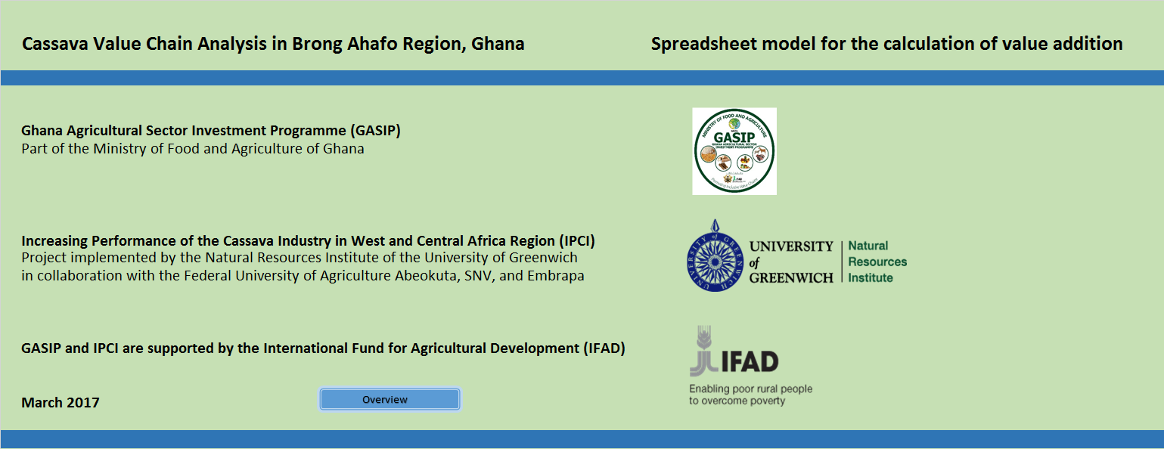

Overview page

The Overview page shows the number of worksheets forming part of the model as well as the hyperlinks ((blue cells) used to navigate between them (by clicking on them)

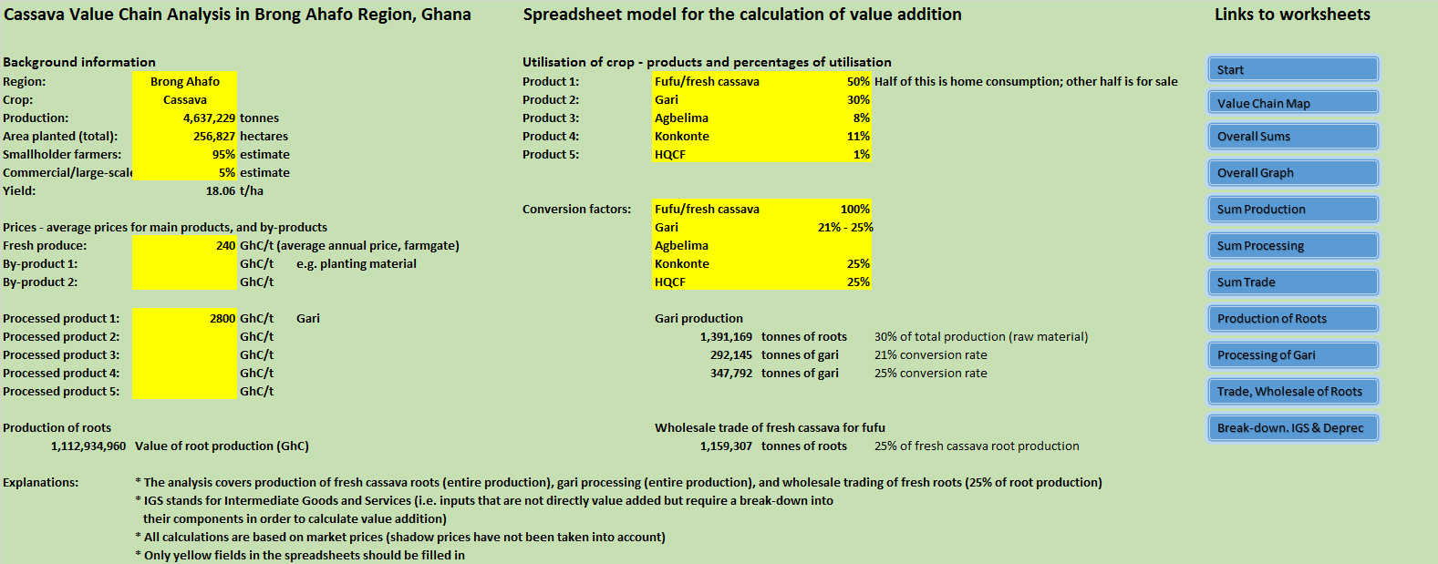

Overview page – information needed

Information to be filled into overview page of the model. For example, this includes information on:
- General understanding of the value chain (to be refined later through various exercises).
- Area covered (i.e. entire nation or a specific region)
- Crop covered (e.g. cassava)
- Production of the crop (in tonnes)
- Area planted per annum or season; ensure the area figures are specified in hectares
- Calculate the yield in tonnes per hectare (done automatically)
- Obtain prices for main product (e.g. fresh cassava roots), by-products, and processed products. In a first step, these prices can be obtained from knowledgeable resource persons (e.g. Ministry of Food and Agriculture, or NGO staff). In a second step the prices will be obtained through a field survey in interviews with farmers, processors, and traders. Prices may have to be adjusted for different weight measures so that they can be expressed in GhC per kilogramme or tonne.

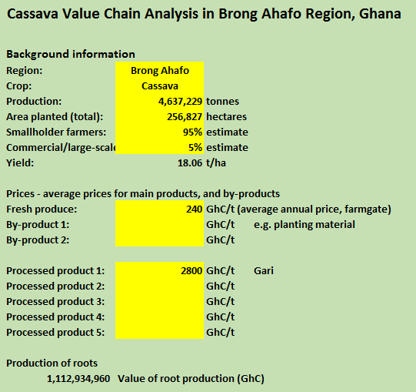

If there are several processed products obtained in the value chain (e.g. in the cassava value chain), then percentages can be estimated as to what each processed product contributes to the value chain.
Conversion factors (e.g. tonnes of raw material used for one tonne of output) serve as a reminder of what current conversion factors are and what can be achieved as part of an upgrading exercise (for example in the case of gari).

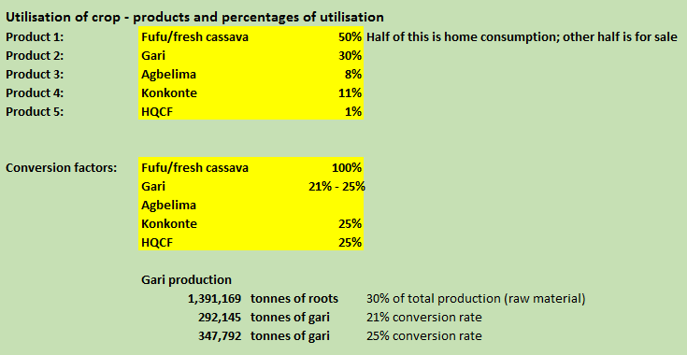

Value chain map

(Usually based on a discussion with group of knowledgeable key informants, using materials such as whiteboard, stickers, marker pens, etc).
The image below is a transcript of a value chain map.
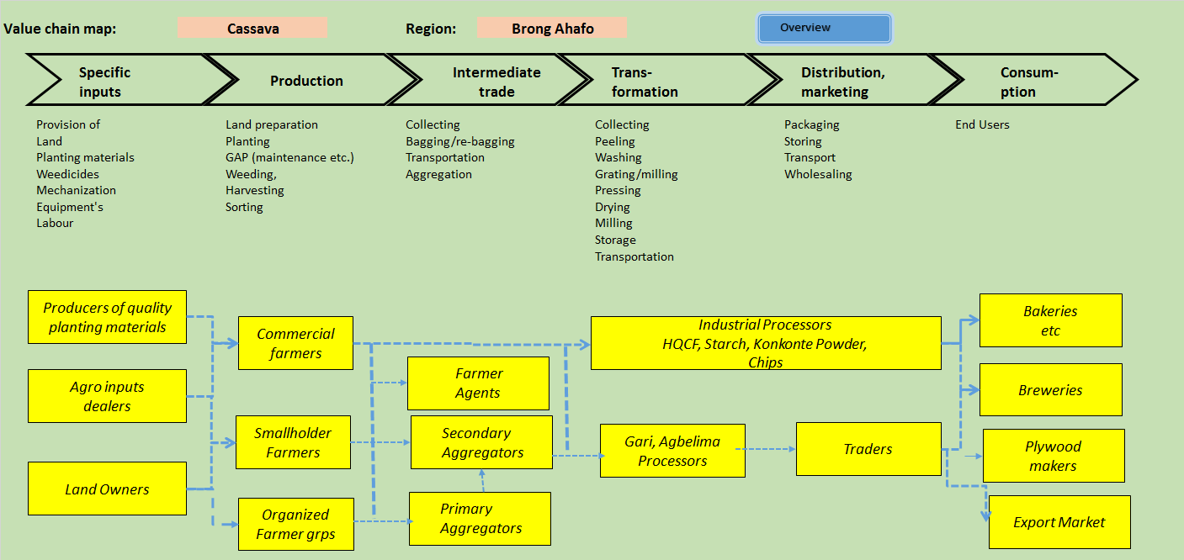

Production page
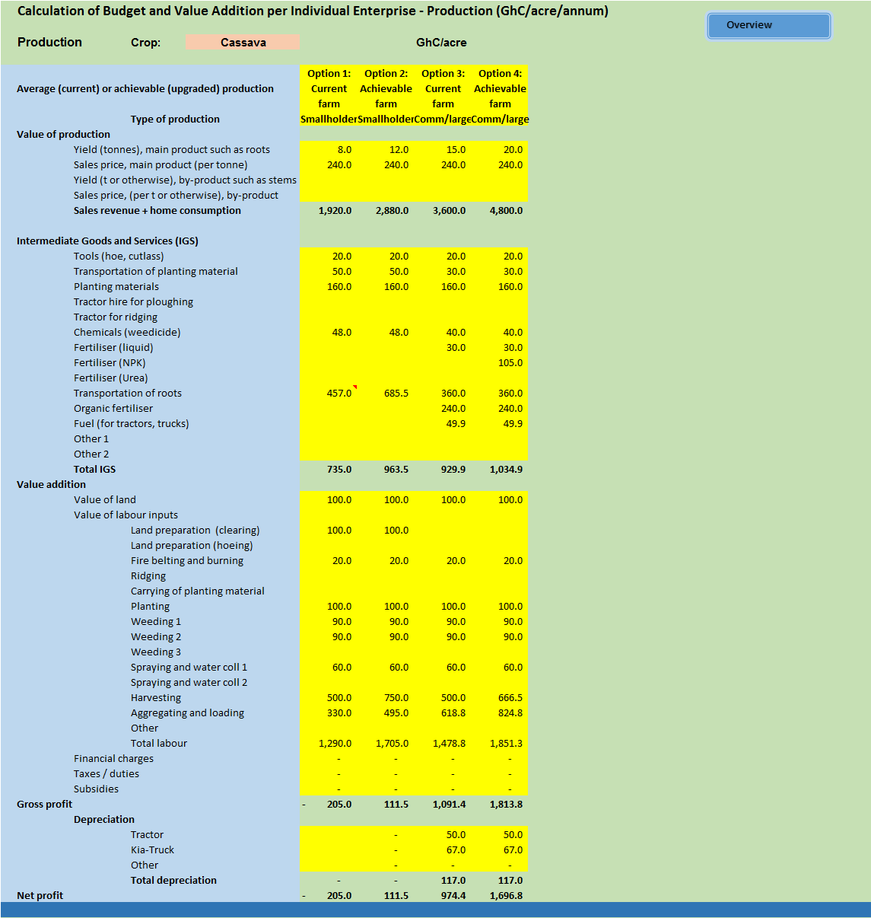

Processing page
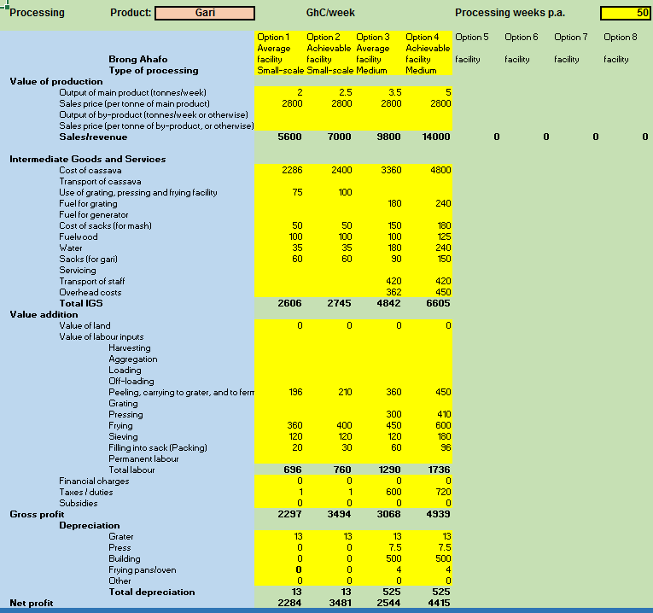

Trading page
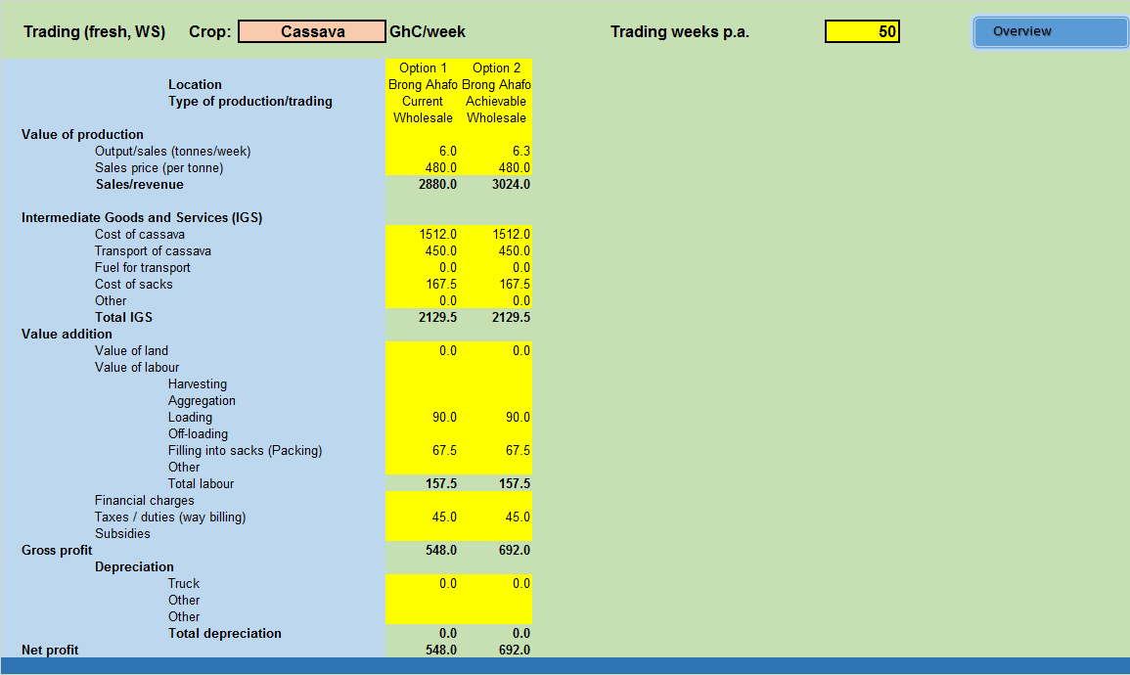

Break-down of IGS and depreciation into value addition
Break-down of Intermediate Goods and Services (IGS) and Depreciation into Value Addition Components
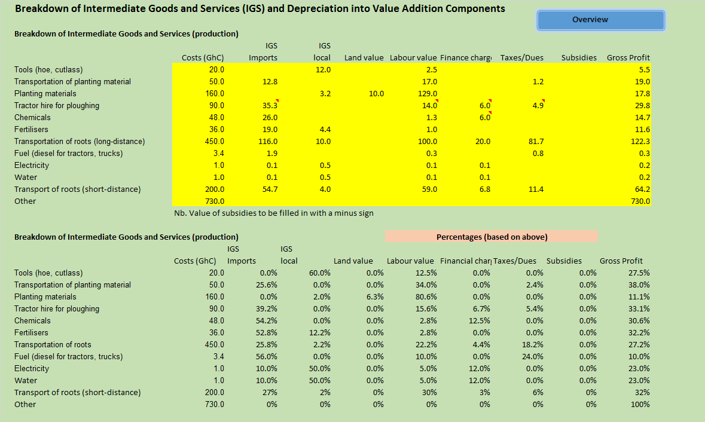

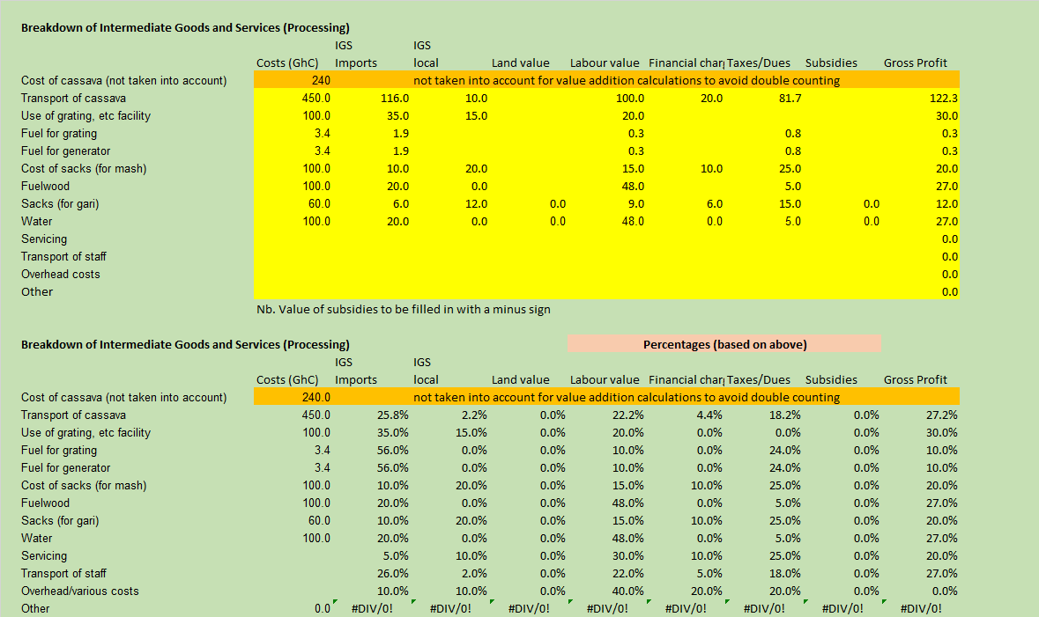

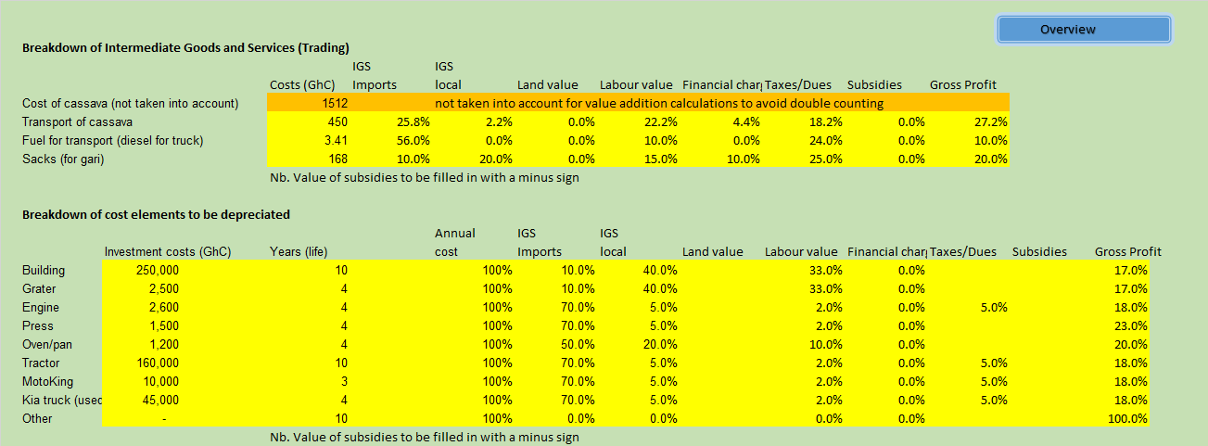

Summary of production
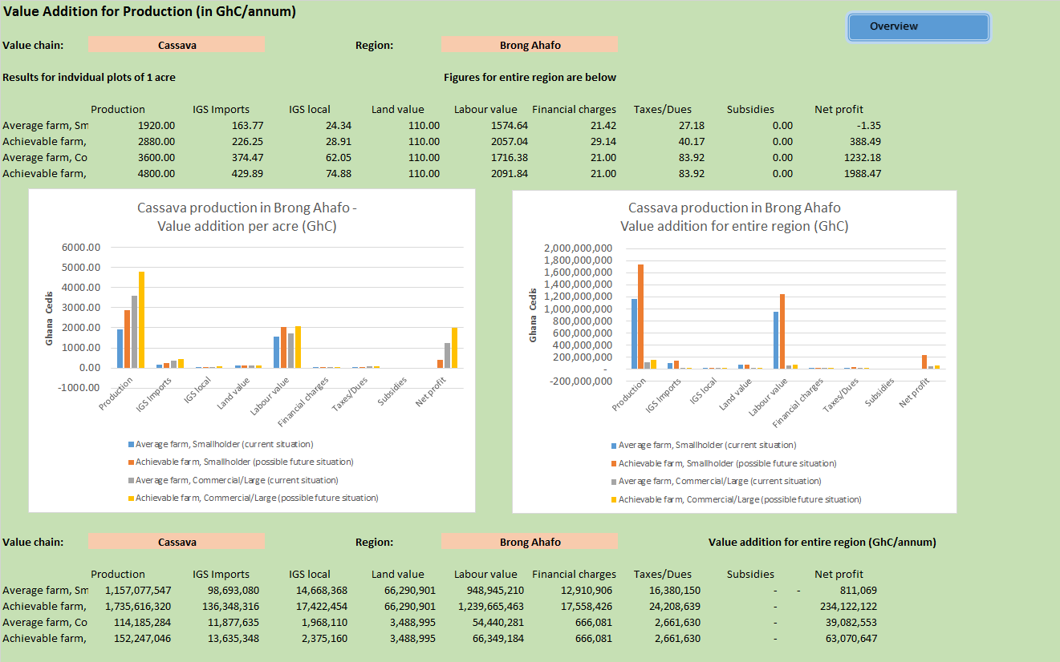

Summary of processing
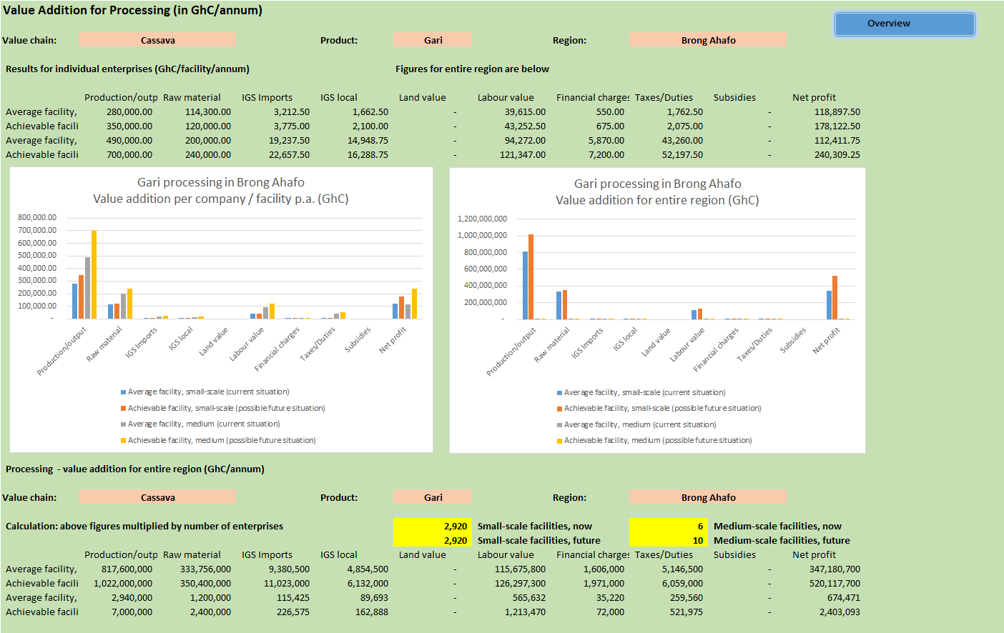

Summary of trading
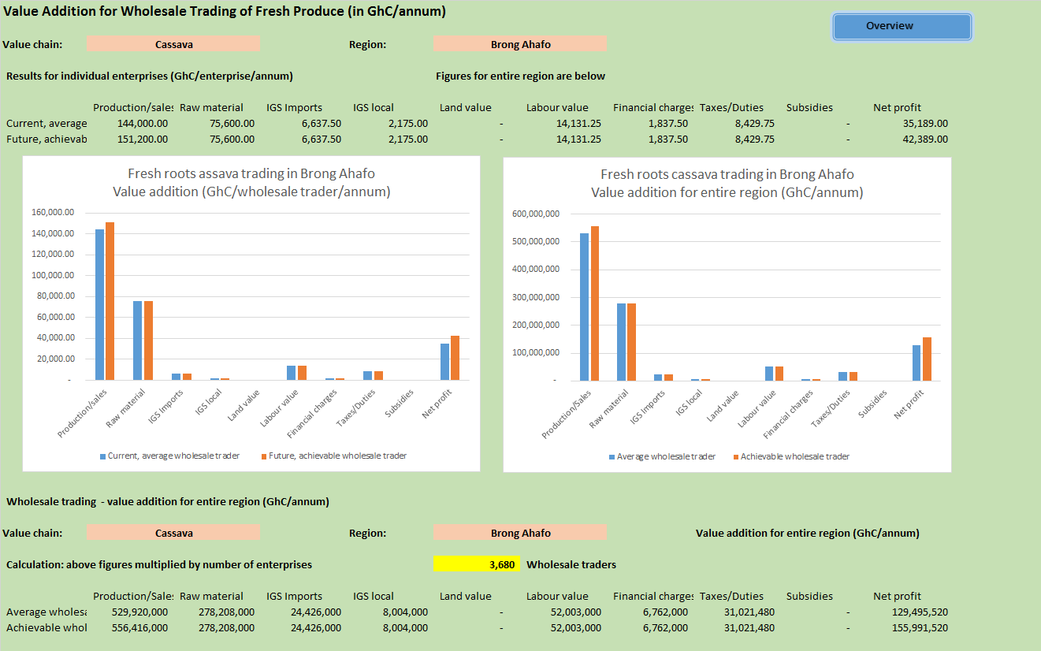

Summary of value addition for the entire region
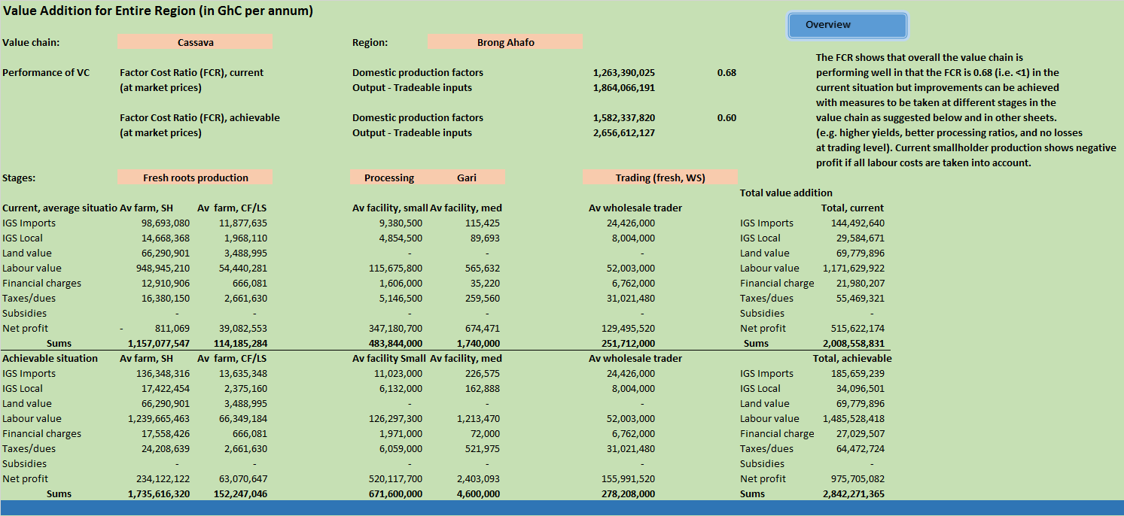

Value addition for entire region (graph)
