 

Farms of the Future: Briefing 1

A promising approach for building adaptive capacity - Lessons from Tanzania

African farmers, rural communities and agricultural stakeholders urgently need to respond to changing climates through adaptation. The ‘Farms of the Future’ approach can be used together with on-going support for participatory action research to build reflective capacity, awareness of challenges and possible solutions amongst farmers and other stakeholders in the agricultural innovation system.

*“The things which impressed us were the formation of the SACCOS, planting of trees, production of improved coffee, ngoro farming, and bee keeping. The challenges are training and capital” (Lushoto farmer)*

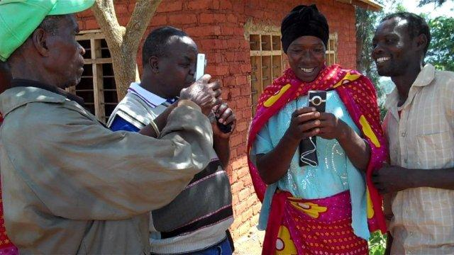

## 1. Introduction

**Key Messages:**

* The Farms of the Future approach comprises climate modelling and analogue tool, farmer and stakeholder study tours and participatory video;
* The climate analogue tool is most useful as a *learning* tool, rather than a predictive one;
* It can support adaptive capacity strengthening by sparking reflection on future scenarios & giving farmers the opportunity to learn from their peers about technological & institutional adaptations;
* Such an initiative is most likely to be effective if embedded within a participatory action research process.

The Farms of the Future approach was conceptualized by a team from the Climate Change, Agriculture and Food security (CCAFS) programme, who also developed a climate analogue tool upon which it is based. This tool identifies places where you can find similar climates to those projected for a chosen site (in this case CCAFS sites) in 2030. The CCAFS concept was then to connect farmers to their possible climate futures via farm visits which would enable them to build a mental picture of what their climate and farming systems might look like in the future, i.e. farmers could learn from what those living in the analogue site do now, and use this knowledge to test specific cropping systems/technologies in their own community, either now or in the future. NRI was commissioned to put this approach in practice and to see if it could be a valuable option to strengthen farmers’ capacity to adapt to climate change. This briefing summarizes the activities undertaken in Tanzania and the findings.

Photo: Farmer training in using easy to use video cameras

## 2. Farms of the Future Approach

The CCAFS Farms of the Future approach aims to strengthen farmer adaptive capacity and comprises two main elements: i) climate modelling (through the use of the analogue tool); ii) farmer exchanges with itineraries based on the climate modelling findings. The NRI team tested this approach and added several elements namely: i) undertaking a study tour journey, rather than a one-off exchange to visit various places with differing characteristics (including climate analogue sites); ii) the identification of other learning opportunities or similar social and environmental challenges as criteria for selecting study tour locations; iii) the participation of agricultural stakeholders in the study tours, and participatory video; iv) participatory modelling prior to the study tour in the CCAFS communities to investigate climate and socio-ecological change v) training farmers to document the study tour using video and sharing this with their own communities.

Emerging from a reading of the literature and the Tanzania study tour the team built up on existing frameworks on adaptive capacity building to add in more dimensions about the process and scale of change). This is because the study tour in particular seems an important way of raising individual awareness and of engaging actors across the agricultural innovation system which could help to engender change at a broader, systemic level – it therefore is most likely to be located in the top left hand box (consciousness of changing climate and the need for adaptation).

*“Here at ours we were growing coffee. Currently our areas have become very hot. For instance here at Mbuzii, coffee is no longer there. Coffee has migrated to our colleagues as a result of hot conditions which have entered. But now there is a lesson which we have seen; tree nurseries...they will give us success, for first environmental conservation”* (Lushoto community member)

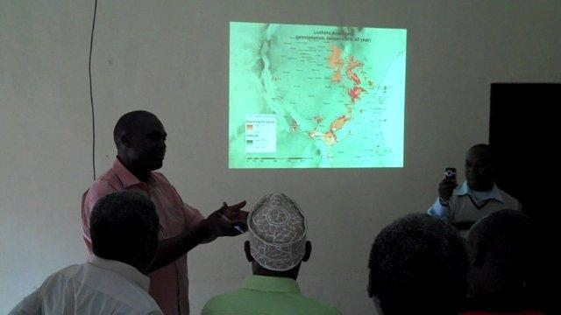

Photo: Explaining the climate dissimilarity maps to stakeholders

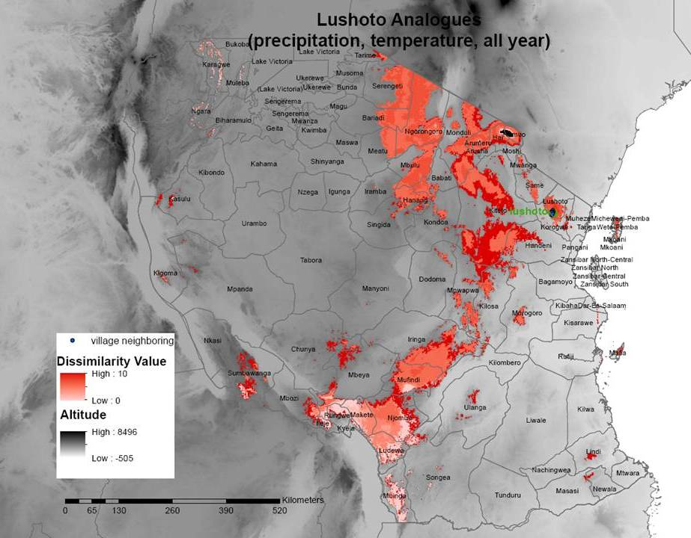

Diagram 1: Climate dissimilarity map – Lushoto Analogues

Figure 1:Framework of adaptive capacity building

Source: Adapted from the Africa Climate Change Resilience Alliance (ACCRA) Local Adaptive Capacity Framework (ACCRA, undated) & Kelleher and Rao (2005).

***Individual & household change***

***Systemic change***

Agricultural innovation system change from local to global

**Informal**

**Formal**

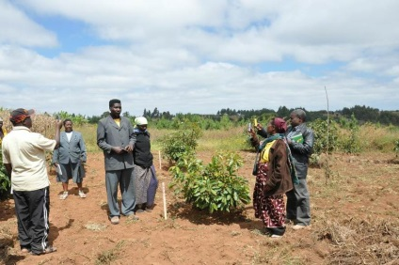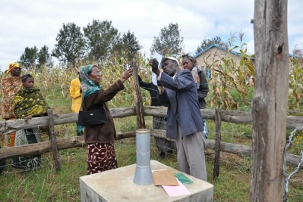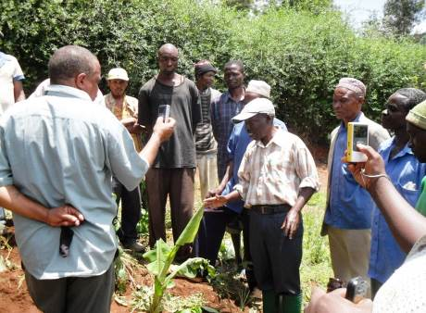

Photo: Farmers visiting crop trials, community managed weather station, and 3D modelling

The main project activities undertaken in Tanzania are outlined in box 1 below.

|  |
| --- |
| **Box 1: Key activities**   * Interaction with the CCAFS climate modelling team in using the climate analogue tool to identify potential sites to implement the farms of the future approach; * Participatory 3D modelling as a tool to facilitate exploration of village change in location x over past decades and of future scenarios; * Selection of farmers from location x and choice of study tour visit sites (locations y, z etc) using climate analogue information, but also informed by learning opportunities and similarities in socio-economic/environmental conditions; * Involvement of broader stakeholders from the agricultural innovation system (AIS) during the whole process; * Training of study tour farmers in how to operate user-friendly video cameras, including creation of two ‘village change’ video in Tanzania; * Facilitation of a study tour with a bus trip to a range of learning sites across Tanzania * Video recording by farmers of the visit to document learning insights; * Sharing of experiences using rapidly edited videos in reflections with communities back at home in location x; * Extending of existing adaptive capacity framework for analysis; * Participatory evaluations of learning during the study tour by farmers and other AIS actors providing information for the team to analyse adaptive capacity building; * Capturing the process throughout, Project team write-up country reports and journal article, and sharing of edited videos as appropriate   Some of these activities are fairly continual throughout the project (e.g. facilitating farmer learning), whereas others are completed at a particular point in the project cycle (e.g. the modelling of village change or the pre-study tour assessment). |

## 3. Learning outcomes

Farmers visited both technical and institutional adaptations in the study tour. In the farmer evaluations of the study tour, the main highlights were seeing and having a go at creating **Matengo pits** – a traditional soil and water conservation method in Mbinga District (the analogue site). The participating farmers were keen to use and adapt this method for use in their own area. They were impressed with the **tree planting** which they saw on the journey. Land scarcity in Lushoto means that their ability to plant trees is fairly limited, but nonetheless interest to act to protect water sources, conserve soil and support reforestation was raised.

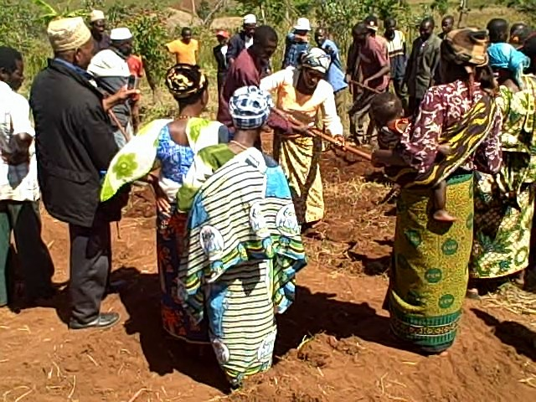

The study tour farmers also ranked a **savings and credit scheme** highly, and plan to establish these in their own communities. They were appreciative of the collective action which they had heard about in relation to this scheme which could also be beneficial in relation to other activities – seeing a successful scheme in operation is valuable. However, overall success may depend on follow-on support. Similarly, the Mbinga **farmer field school group** impressed the visiting farmers, because of what they had achieved with the **coffee nursery** amongst other things. **Community managed weather stations** were also positively appraised. **Beekeeping, fish rearing and new avocado tree** varieties are examples of other innovations that were highly valued by the participants.

*Photo: Women from the host village demonstrating the Matengo pits*

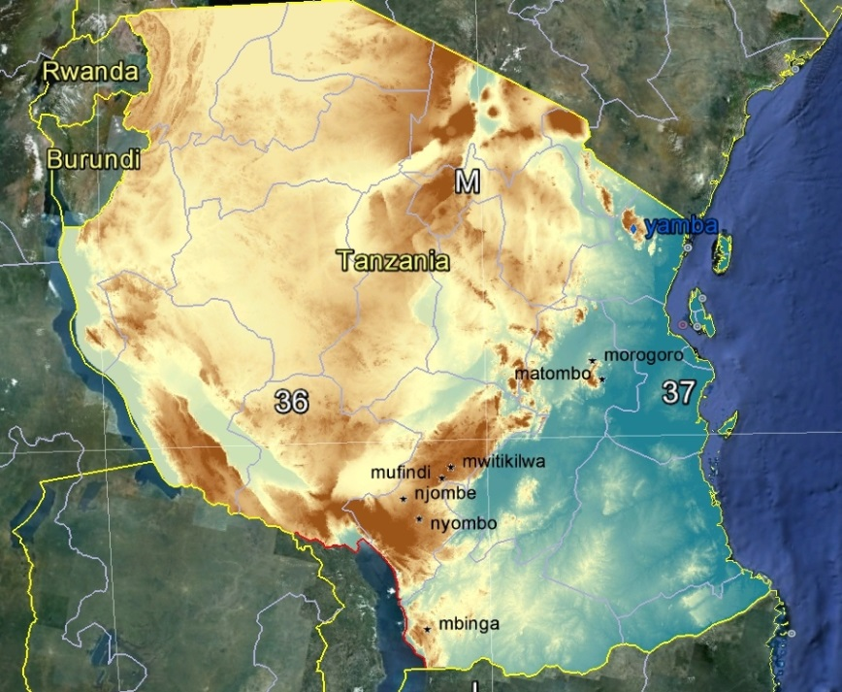Other agricultural stakeholders (e.g. district extension officers, NGOs, community development staff, traders) said that the study tour had been valuable for them and raised their awareness on climate change challenges ahead. However, land scarcity in Lushoto may mean that with climate change and other pressures on smallholders, exit from agriculture becomes a necessary adaptation strategy. **Livelihood diversification** is important to retain attract the next generation in farming, but for some outmigration may be the only option.

*“Another thing which we have seen and been impressed is the equipment for measuring weather conditions” (female farmer, village Lushoto).*

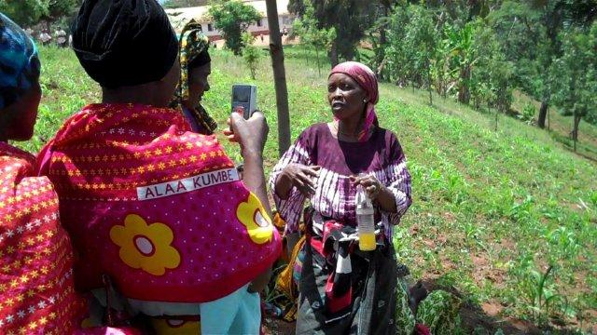

Map: Study tour journey from Yamba and Mbuzii villages in Lushoto, North East Tanzania to South West Tanzania

## Challenges

* Climate modelling has inherent uncertainties and this is exacerbated in highly dissected upland areas, due to the major changes in altitude over short distances complicating the picture.

*“We saw our fellows’ success from the cooperation they have. So then the essential thing which we emulated there is cooperation which can bring about success. So cooperation is an essential thing in every activity. We went out of the SACCOS [savings & credit scheme] after witnessing success and went to the market. In the market too we found the same cooperation which gave them success to form something which gives them development in that area… There villagers there have become entrepreneurial as a result of their SACCOS. So we have come to realise that if there is leadership and if there is cooperation they bring success in the community” (Study tour Lushoto farmer)*

* A great deal of very useful interaction took place between the CCAFS modellers and the NRI team in the identification of potential analogue sites, but this may not be feasible at scale with a large number of similar initiatives.
* The social and environmental context, beyond weather and climate, needs to be taken into account in the final selection of analogue sites to visit, which means a wide range of other information needs to be available to the organizers.
* The practical logistics of organizing a study tour can be demanding and should not be under-estimated: One of the climate analogue sites was at the opposite side of the country, and Tanzania is very large – hence to complete the study tour involved a long bus journey. On such a long journey it is not always possible to stick precisely to the study tour itinerary.
* Preparatory communications with the hosts are important to ensure that they are clear on the purpose of the visit and the type of interaction between farmers and stakeholders being sought – in this case practical demonstrations, learning by doing, sharing of experiences and informal discussions, rather than formal presentations and structured debate.
* To assess the outcomes of this activity would require follow on research at a later date to explore whether the study tour had sparked new thinking and practical action – with a focus on assessing its contribution to an overall participatory action research process. Much depends on the quality of the participatory action process within which such an activity is embedded.
* Gender inequalities may constrain women’s mobility and hence participation in a long-distance study tour. But women were able to participate in the study tour and the fact that they were given equal roles (e.g. filming) and space to speak provides an important message for other participants and for the rest of the community viewing the farmers’ films.

## 5. Lessons

**The climate analogue tool**

The climate analogue tool is a useful *learning* tool, when embedded in a participatory process, rather than being seen as *a predictive tool* for use in finding future climates and agricultural scenarios.The latter approach raises too many risks of misleading farmers and thus raises ethical questions. Participatory enquiry activity of this type can be valuable for farmers and other agricultural stakeholders if facilitated well and with the right facilitation, training, technical skills and equipment (e.g. video cameras, editing skills). Ultimately, building adaptive capacity will require far-reaching institutional, structural and policy change, but such a process can *contribute* to increasing awareness which is currently very limited at the local and district levels of the challenges of climate change and of thinking through *possible* future scenarios. It is critically important to engage actors across the agricultural innovation system as adaptive capacity strengthening cannot be achieved by farmers alone.

**Communicating climate change science**

More work is needed to find appropriate and ethical ways to communicate with farmers and other stakeholders about the *global* causes of climate change, the difference between climate variability and longer term climate change, and potential solutions. Further, understanding climate modelling can be challenging for non-climate scientists at any level and more resources are needed to enable learning in this area (e.g. at district level).

The psychology and ethics of the process are important – taking farmers to visit places where the climate is much more challenging could be overwhelming and have a negative impact on willingness to act. Future climate modelling should not be thought of as providing a picture of a future climate, and especially what the farms and adaptations will be – human creativity and socio-ecological dynamics of systems mean prediction is not possible and would be misleading. Thus climate analogue tools should be used more as a means of education in terms of climate science and of sparking learning processes that support positive development and climate related action.

The idea of a learning *journey* is thus proposed to enable farmers and other stakeholders to explore a variety of challenges and learning opportunities to maximize the usefulness of the tour. Including visits to communities who are known to be practicing promising adaptations or adaptation projects may also be advisable.

**Participatory 3D modelling exercise**

A participatory exercise was carried out in the study tour farmers’ villages, where women and men worked on separate 3D models of their area (in the past, present and future). Gender balance was sought in terms of the number of male and female participants in the study tour – some women were not allowed to participate, but several women farmers did join the study tour and had received training in using the video cameras. During the study tour women, men and other AIS stakeholders were asked to reflect on what they had seen in separate discussion groups – to encourage women to feel confident to speak up. The role of women in the study tour as equally important participants is an important demonstration of greater equality in gender relations in and of itself to the other male participating farmers and to those in the community back home who saw the female and male farmers actively participating in the video footage (which was produced by them).

The study tour process itself was warmly appraised by participants as there was a sense of camaraderie on the ‘climate change tour bus’ – sharing a long journey together can lead to bonding between participants and unexpected outcomes.

**Participatory video**

Participatory video is an important tool for supporting farmers to document their own learning and for sharing this with their own communities – which increases opportunities for strengthening adaptive capacity. However, it is important to distinguish between video used for social documentary or public relations purposes, and video as used here where farmers are trained to use the cameras themselves and are involved in the editing process. In this process in Tanzania participatory video was a central part of the process – it strengthened the learning and sharing process between the participants and also enabled a much wider audience (the communities in Lushoto) to see where their representatives had travelled to and what they had experienced.

## 6. Conclusion

The Farms of the Future approach, combining climate modelling/ analogue tool, farmer study tours, and participatory video, can – when embedded in a participatory research process - support adaptive capacity strengthening. Although a short-term initiative such as this is unlikely to shift entrenched norms and structural barriers to adaptation, it can help to introduce ideas about longer term climate change, and build greater consciousness of climate change challenges and awareness of the need to act. In particular, it can help to articulate demand for action from farmers and other stakeholders in the agricultural innovation system and support reflection amongst participants on what potential future scenarios might look like. Participants identified a number of technological and institutional adaptations which they valued from the study tour and have shared with their own communities. Thus, the Farms of the Future approach can complement on-going participatory action research in agricultural adaptation in poorer and resource constrained communities. There are also a huge number of ways in which this type of initiative could be applied across international development, to support critical reflection, horizon scanning and sharing of information amongst farmers and wider stakeholders for positive action.



|  |
| --- |
| **For further information:** <http://projects.nri.org/farmsofthefuture>;  **Project team:** Valerie Nelson: [v.j.nelson@gre.ac.uk](mailto:v.j.nelson@gre.ac.uk); Richard Lamboll: [r.i.lamboll@gre.ac.uk](mailto:r.i.lamboll@gre.ac.uk); Nick Nathaniels: [nicquist@gmail.com](mailto:nicquist@gmail.com) |